**Credential card download flow:**

1)Generate a credential

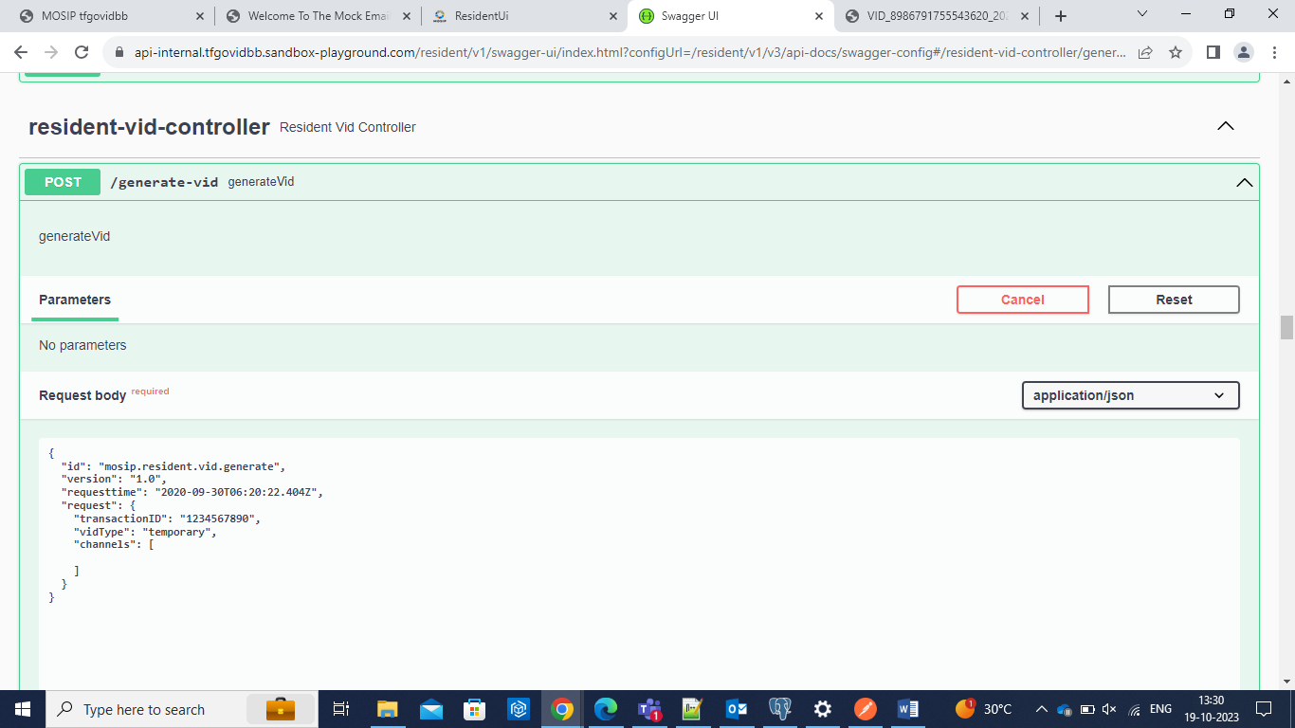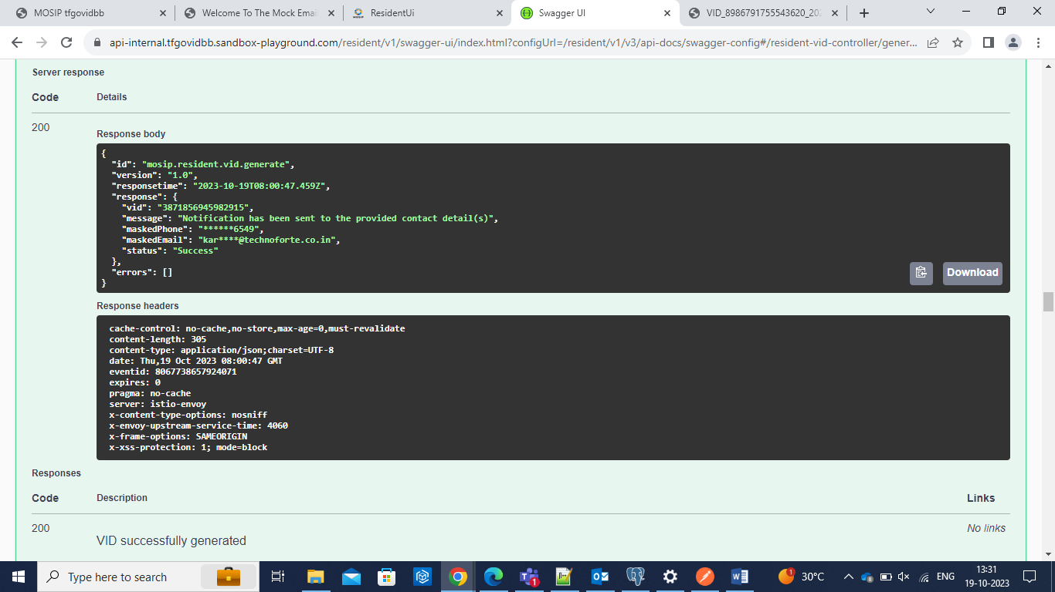

2)Notification for credential generation

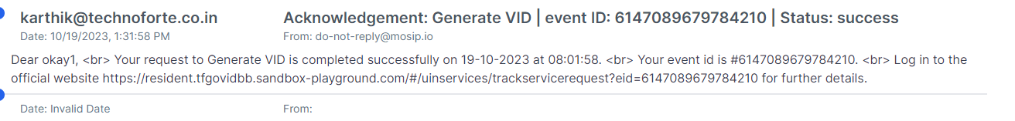

3) Request Credential Card

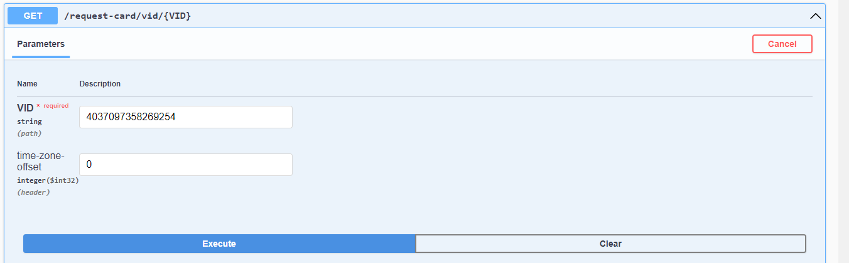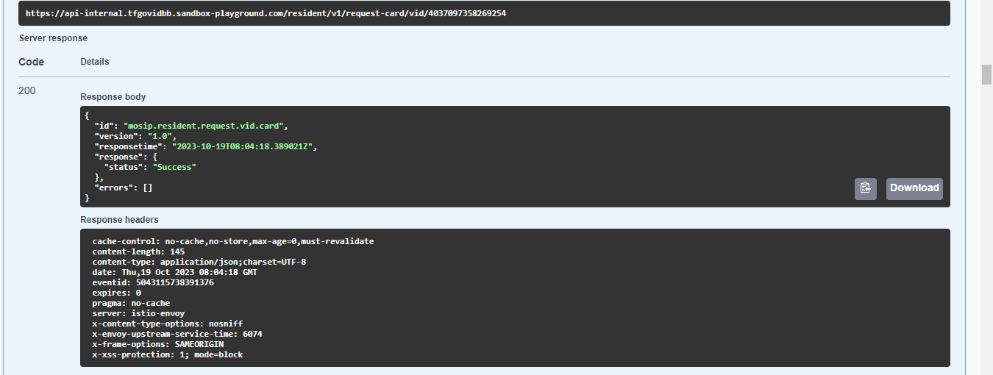

4)Notification for Acknowledgement

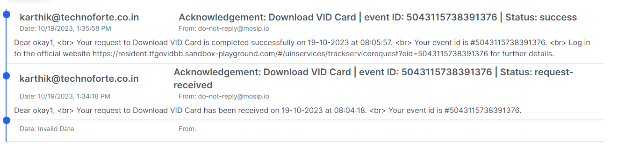

5)Download card with Event id.

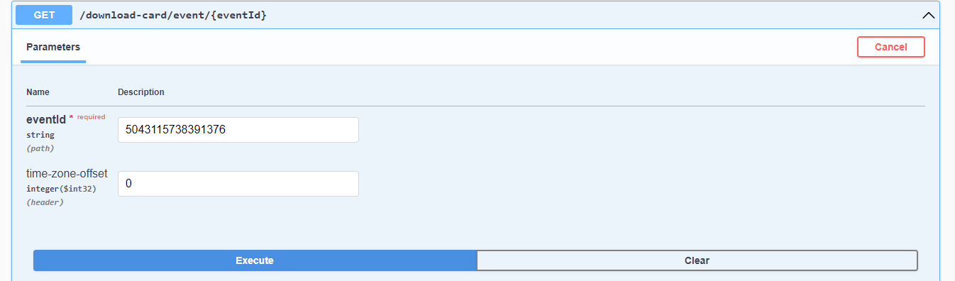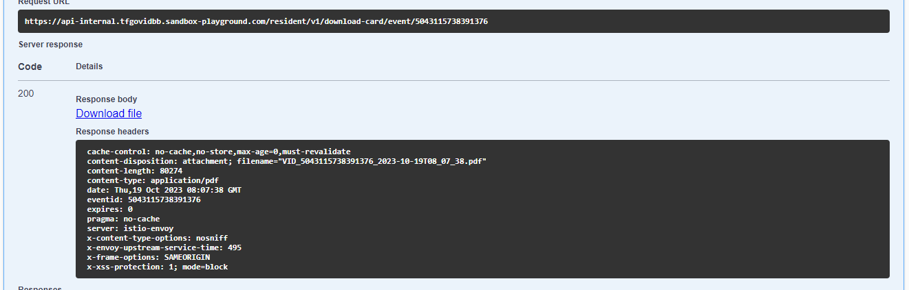



6)Downloaded credential

